9.64: a) For constant angular acceleration 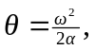and so 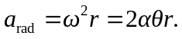
b) Denoting the angle that the acceleration vector makes with the radial direction as , and using Equations (9.14) and (9.15),
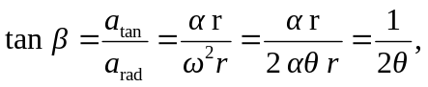
so 